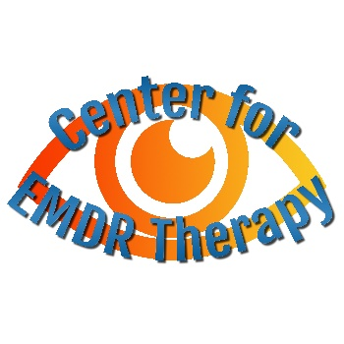
Center for EMDR Therapy
sherilynlacy@gmail.com
centerforemdr.com
5866 Karen Street

Ooltewah, TN 37363

423-910-9430
Request for Fee Adjustment

I hereby state that the $100/session fee presents a financial hardship for me, and request a fee adjustment so that I can receive 12 sessions of EMDR Therapy. (I understand that I can re-apply for further sessions after I have received 12 sessions.)

My approximate net income for the prior calendar year was: __________________________

Paying the full $100 fee represents a financial hardship for me because: _________________

____________________________________________________________________________

____________________________________________________________________________

____________________________________________________________________________

____________________________________________________________________________

______I request a 25 % adjustment, and can pay $ 75.00/session.

______I request a 50 % adjustment, and can pay $ 50.00/session.

Client: _____________________________________________________________________

Date: ______________________________________________________________________

